Contents

1. DATABASE IMPORT INSTRUCTIONS 2

1. Start MySQL Workbench 2

2. Create “test” database 2

3. Enter database basic parameters 3

4. Finalize database creation 4

5. Create new user specifically for “test” database 5

6. Import database structure and data 6

# DATABASE IMPORT INSTRUCTIONS

## Start MySQL Workbench

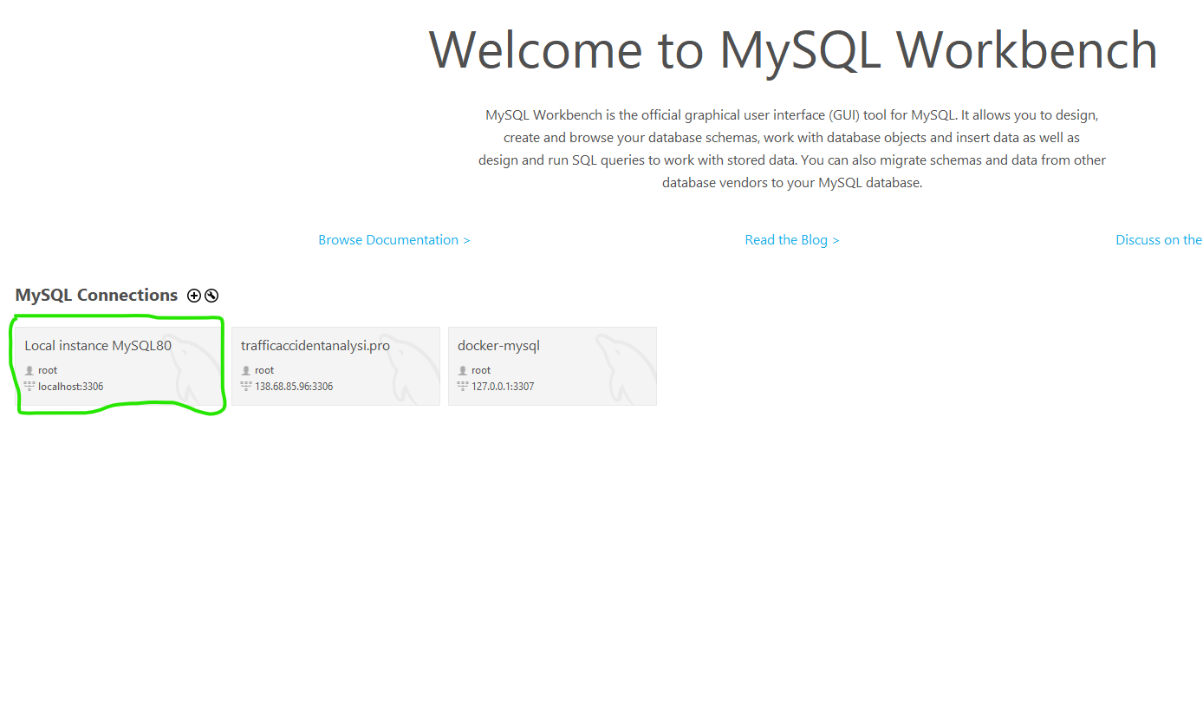

Figure 1 - Starting MySQL Workbench

## Create “test” database

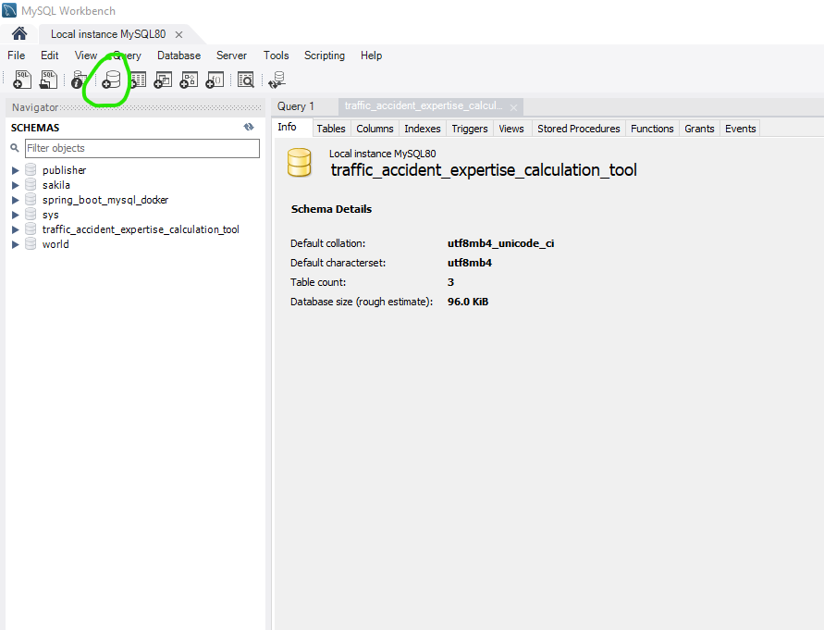

Figure 2 - Select "crete database" option

## Enter database basic parameters

Enter “test” for schema name, “utf8mb4” for charset and “utf8mb4_unicode” for collation.

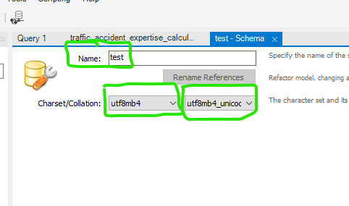

Figure 3 - Schema name and charset/collation

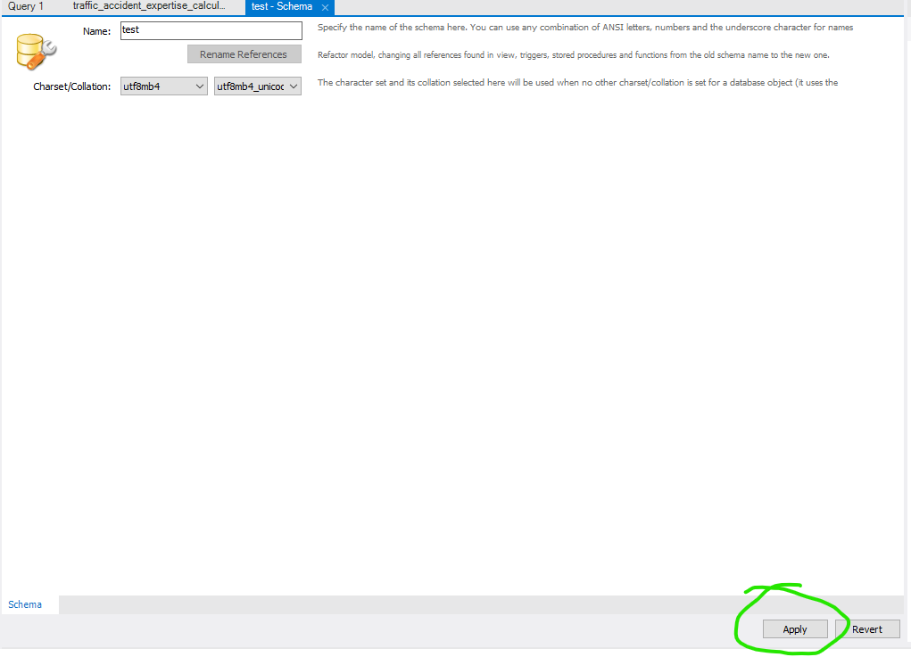

Figure 4 - Click on "Apply"

## Finalize database creation

Leave the default settings and click on “Apply” again.

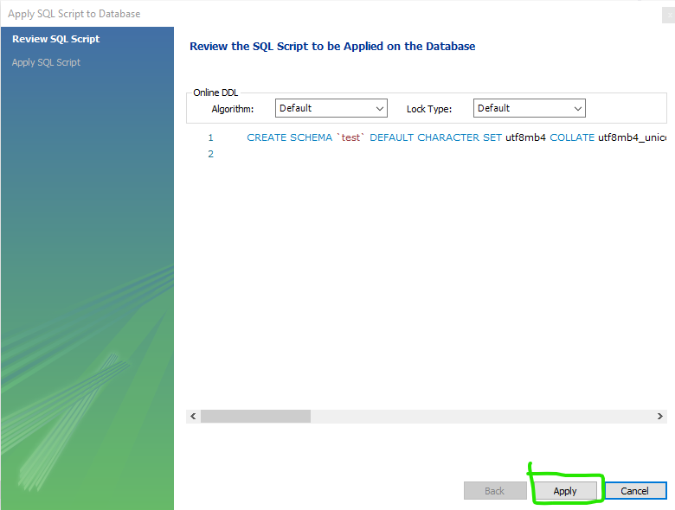

Figure 5 - Click on "Apply" again

Schema “test” is created.

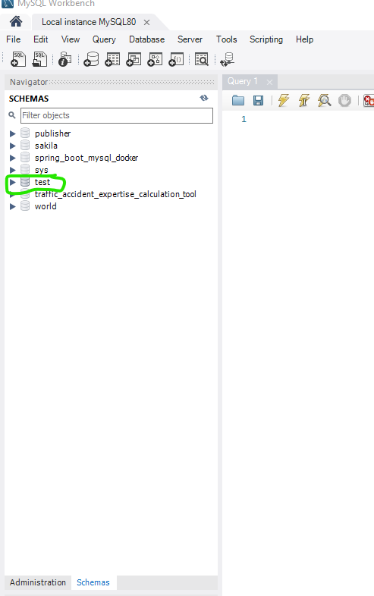

Figure 6 - Schema "test" created

## Create new user specifically for “test” database

Create new user, with username “test” and password “test”. This user will only have access to “test” database.

Copy next queries to MySQL Workbench.

CREATE USER 'test'@'localhost' IDENTIFIED WITH mysql_native_password BY 'test';

GRANT ALL PRIVILEGES ON test . * TO 'test'@'localhost';

FLUSH PRIVILEGES;

Then, **select them all in the MySQL Workbench editor**, and click on “thunder” symbol.

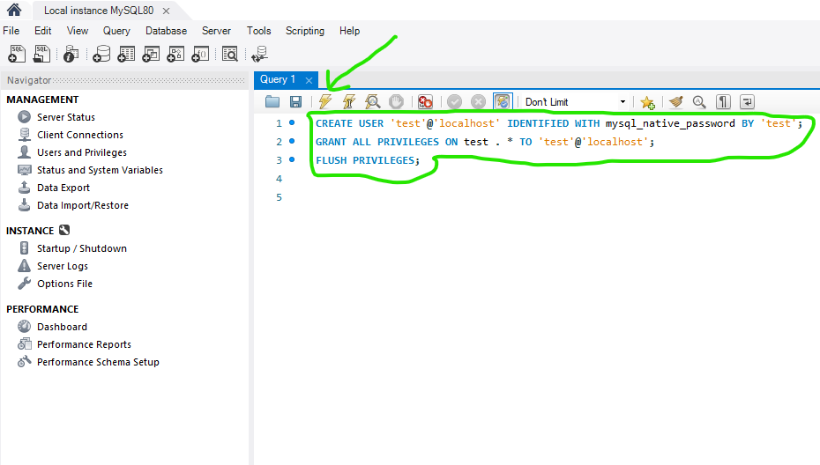

Figure 7 - Queries for creating new user

## Import database structure and data

Click on “Data Import/Restore” on “Administration” view.

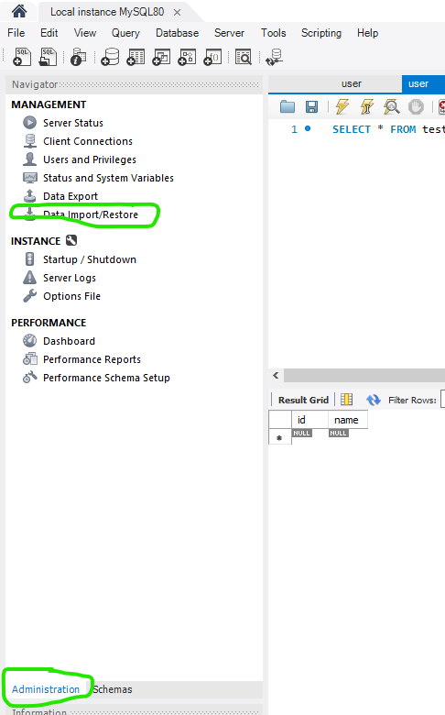

Figure 8 - Import data

1. Select option “Import from Self-Contained File”.
2. Then, select db.sql file, from the cloned repository from github.
3. Select “test” as target schema.
4. Click on “Start Import”.

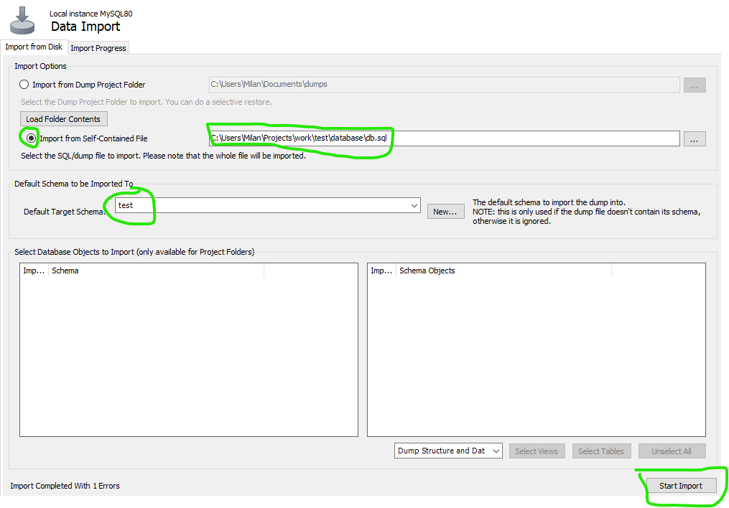

Figure - Import database structure and data